**KWAME NKRUMAH UNIVERSITY OF SCIENCE AND TECHNOLOGY**

**CHEMICAL ENGINEERING DEPARTMENT**

**CHE 158: INTRODUCTION TO INFORMATION TECHNOLOGY**

**INSTRUCTOR:** Dr. (Mrs.) Mizpah A. D. Rockson

LECTURE 6: **SYSTEM UNIT**

**Learning Objectives**

At the end of the lecture the student is expected to be able to do the following:

1. Differentiate between the four basic types of system units.
2. Describe system boards, including sockets, slots, and bus lines.
3. Recognize different microprocessors, including microprocessor chips and specialty processors.
4. Compare different types of computer memory, including RAM, ROM, and flash memory.
5. Explain expansion slots and cards.
6. Describe bus lines, bus widths, and expansion buses.
7. Describe ports, including standard and specialized ports.
8. Identify power supplies for desktop, laptop, tablet, and mobile devices.
9. Explain how a computer can represent numbers and encode characters electronically.

**6.0 Introduction**

Why are some microcomputers more powerful than others? The answer lies in three words: **speed**, **capacity**, and **flexibility**. This lecture will help you to evaluate whether or not an existing microcomputer system is powerful enough for today’s new and exciting applications.

A microcomputer is a collection of electronic circuitry. While there is no need to understand how all these components work, it is important to understand the principles. Once you do, you will be able to determine how powerful a particular microcomputer is. This will help you judge whether it can run particular kinds of programs and can meet your needs as a user.

Competent end users need to understand the functionality of the basic components in the system unit, including the system board, microprocessor, memory, expansion slots and cards, bus lines, ports, cables, and power supply units.

**6.1 System Unit**

The **system unit,** also known as the **system chassis,** is a container that houses most of the electronic components that make up a computer system. There are a variety of different categories or types of system units.

All computer systems have a system unit. For microcomputers, there are four basic types.

**6.1.1 Desktops**

This is the most powerful type of microcomputer. Most ***desktops*** have their system unit in a separate case. This case contains the system’s electronic components and selected secondary storage devices. Input and output devices, such as a mouse, keyboard, and monitor, are located outside the system unit. Desktop system units that are placed vertically are sometimes referred to as a ***tower unit*** or ***tower computer***.

Some desktop computers, like Apple’s iMac, have their monitor and system unit housed together in the same case. These computers are known as an ***all-in-one***.



**Figure 6.1 Desktop system units**

**6.1.2 Notebook**

Although typically not as powerful as desktops, ***notebooks*** are portable and much smaller. Their system units are housed with selected secondary storage devices and input devices (keyboard and pointing device). Located outside the system unit, the monitor is attached by hinges. Notebooks are often called laptops.

***Netbooks*** are a type of notebook. They are smaller, less powerful, and less expensive than other notebooks. Netbooks are designed to support on-the-go web browsing and e-mail access. They reduce space and weight by leaving out components such as optical drives.



**Figure 6.2 Notebook system units**

**6.1.3 Tablets**

***Tablets***, also known as ***tablet computers***, are the newest and one of the most popular types of computer. The system units are located behind the monitors.

Tablets are smaller, lighter, and generally less powerful than notebooks. Like a notebook, tablets have a flat screen but typically do not have a standard keyboard. Instead, tablets typically use a virtual keyboard that appears on the screen and is touch-sensitive.

One distinguishing feature among tablet computers is the operating system that controls their operations. For example, Apple’s iPad uses the mobile operating system iOS. It is capable of running apps specifically designed for it. Many other tablets use Microsoft’s Windows 8 operating system and can run many general-purpose applications as well as apps specifically designed for it.

**6.1.4 Handhelds**

Handheld computers are the smallest and are designed to fit into the palm of one hand. These systems contain an entire computer system, including the electronic components, secondary storage, and input and output devices. By far the most popular handheld computer is the ***smartphone***. These devices are smaller and generally less powerful than tablets.

Smartphones greatly extend the capabilities of a cell phone by providing computing power. In addition to capturing and sending audio and video, smartphones run apps, connect to the Internet, and more. Their system unit is located behind the display screen and keypad.

**6.1.5 Components**

While the actual size may vary, each type of system unit has the same basic system components including system board, microprocessor, and memory. These components can generate great amount of heat that can damage a computer system.



**Figure 6.3 System unit components**

**6.2 System board**

The **system board** is also known as the **main** or **motherboard.** The system board controls communications for the entire computer system. Every component within the system unit connects to the system board. All external devices including the keyboard, mouse, and monitor connect to the system board. It acts as a data path and traffic monitor, allowing the various components to communicate efficiently with one another.

On a desktop computer, the system board is typically located at the bottom of the system unit or along one side. It is a large flat circuit board covered with a variety of different electronic components including sockets, slots, and bus lines.

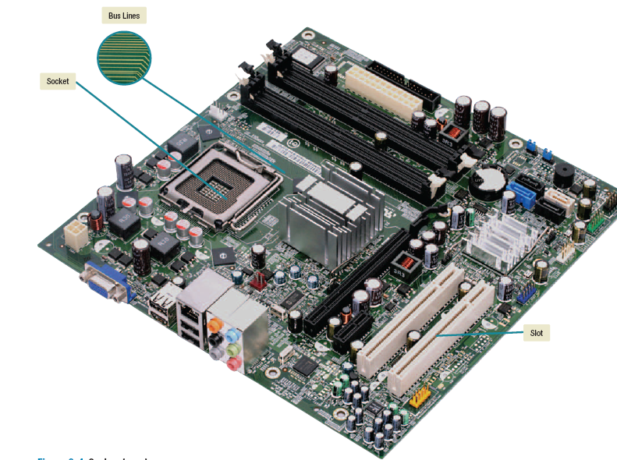

**Figure 6.4: System board**

* **Sockets provide** a connection point for small specialized electronic parts called chips. **Chips** consist of tiny circuit boards etched onto squares of sandlike material called silicon. These circuit boards can be smaller than the tip of your finger. A chip is also called a **silicon chip, semiconductor,** or **integrated circuit.** Chips are mounted on **carrier packages.** These packages either plug directly into sockets on the system board or onto cards that are then plugged into slots on the system board. Sockets are used to connect the system board to a variety of different types of chips, including microprocessor and memory chips.
* **Slots provide** a connection point for specialized cards or circuit boards. These cards provide expansion capability for a computer system. For example, a wireless networking card plugs into a slot on the system board to provide a connection to a local area network.
* Connecting lines called **bus lines** provide pathways that support communication among the various electronic components that are either located on the system board or attached to the system board. It also links the microprocessor chip with other hardware. A bus is a data pathway along which bits travel.

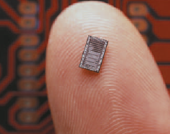 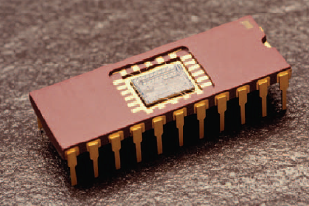

**Figure 6.5: Chip Figure 6.6: Chip mounted onto a carrier package**

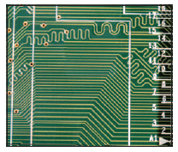

**Figure 6.7: Bus lines**

**6.3 Microprocessor**

In a microcomputer system, the **central processing unit (CPU)** or **processor** is contained on a single chip called the **microprocessor.** The microprocessoris the “brains” of the computer system. It has two basic components: **the control unit** and **the arithmetic-logic unit**.

* **Control unit** tells the rest of the computer system how to carry out a program’s instructions. It directs the movement of electronic signals between memory, which temporarily holds data, instructions, and processed information, and the arithmetic-logic unit. It also directs these control signals between the CPU and input and output devices.
* **Arithmetic-logic unit (ALU)** performs two types of operations: **arithmetic** and **logical**. **Arithmetic operations** are the fundamental math operations (+, -, ×, ÷). **Logical operations** consist of comparisons. That is, two pieces of data are compared to see whether one is equal to ( = ), less than (<), or greater than (>) the other.

**6.3.1 Microprocessor chip**

Chip processing capacities are often expressed in word sizes. A **word** is the number of bits (such as 16, 32, or 64) that can be accessed at one time by the CPU. The more bits in a word, the more data a computer can process at one time. As mentioned previously, eight bits group together to form a byte. A 32-bit-word computer can access 4 bytes at a time. A 64-bit-word computer can access 8 bytes at a time. Therefore, the computer designed to process 64-bit words has greater processing capacity.

Other factors affect a computer’s processing capability including the following:

* **Clock speed** which is used to represent the processing speed of a microcomputer which is related to the number of times the CPU can fetch and process data or instructions in a second. Older microcomputers typically process data and instructions in millionths of a second, or microseconds. Newer microcomputers are much faster and process data and instructions in billionths of a second, or nanoseconds. Supercomputers, by contrast, operate at speeds measured in picoseconds—1,000 times as fast as microcomputers. Logically, the higher a microprocessor’s clock speed, the faster the microprocessor.
* **Multiple processing ability** Some processors can handle multiple instructions per cycle or tick of the clock; this means that the clock speed comparisons can only be made between processors that work the same way.

The two most significant recent developments in microprocessors are the **64-bit processor** (which was originally designed for large mainframe and supercomputers are now available for microcomputers) and the ***multicore chip*** (which can provide two or more separate and independent CPUs to run 2 or more applications on a single computer). For example quad-core processor could have one core computing a complex excel spreadsheet, a second core creating a report using Word, a third core locating a record using Access, and a forth core running a multimedia presentation.

For multicore processors to be used effectively computers must understand how to divide tasks into parts that can be distributed across each core—an operation called ***parallel processing*.** Operating systems such as Windows 7, Windows 8 and Mac OS X support parallel processing. Software developers use this technology for a wide range of applications from scientific programs to sophisticated computer games.

**6.3.2 Specialty processors**

In addition to microprocessor chips, a variety of more specialized processing chips have been developed.

* **Coprocessors** are specialty chips designed to improve specific computing operations. One of the most widely used is the **graphics coprocessor,** also called a **GPU (graphics processing unit).** These processors are designed to handle a variety of specialized tasks such as displaying 3-D images and encrypting data.
* **Smart cards** are plastic cards the size of a regular credit card that have an embedded specialty chip. Many colleges and universities provide smart cards to their students for identification.
* **RFID tags** are specialty chips embedded in merchandise to track their location. The International Civil Aviation Organization has proposed inserting RFID chips in over a billion passports to track visitors as they enter or leave the United States.

**6.4 Memory**

Memory is a holding area for data, instructions, and information. Like microprocessors, **memory** is contained on chips connected to the system board. There are three well-known types of memory chips: **random-access memory** (**RAM**), **read-only memory** (**ROM**), and **flash memory**.

**6.4.1 Random-access memory (RAM)**

RAM chips hold the program (sequence of instructions) and data that the CPU is presently processing. RAM is called temporary or volatile storage because everything in most types of RAM is lost as soon as the microcomputer is turned off or when there is power failure or other disruption of the electric current going to the microcomputer. For this reason, it is advisable to save your work in progress on a secondary storage device, which is permanent or nonvolatile storage (e.g. hard disk, optical discs, etc). RAM storage is expressed in MB (megabyte), GB (gigabyte), or TB (terabyte).

Another term you can hear in connection with RAM is **cache memory** or **RAM cache** (pronounced “cash”). Cache memoryimproves processing by acting as a temporary high-speed holding area between the memory and the CPU. The computer detects which information in RAM is most frequently used and then copies that information into the cache. When needed, the CPU can quickly access the information from the cache.

Some applications may require higher amount of memory. Even if your computer does not have enough RAM to hold a program, it might be able to run the program using **virtual memory.** Most of today’s operating systems support virtual memory. With virtual memory, large programs are divided into parts and the parts are stored on a secondary device, usually a hard disk. Each part is then read into RAM only when needed. In this way, computer systems are able to run very large programs.

Fortunately, additional RAM can be added to a computer system by inserting an expansion module called a **DIMM (dual in-line** **memory module)** into the system board. Other types of RAM include DRAM, SDRAM, DDR, and Direct RDRAM.

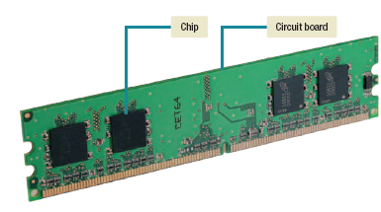

**Figure 6.8: RAM chips mounted on circuit board**

**6.4.2 Read-only memory**

ROM chips have information stored in them by the manufacturer. Unlike RAM chips, ROM chips are not volatile and cannot be changed by the user. “Read only” means that the CPU can read, or retrieve, data and programs written on the ROM chip. However, the computer cannot write—encode or change—the information or instructions in ROM. ROM chips typically contain special instructions for basic computer operations. For example, ROM instructions are needed to start a computer, to access memory, and to handle keyboard input.

**6.4.3 Flash memory**

Flash memoryoffers a combination of the features of RAM and ROM. Like RAM, it can be updated to store new information. Like ROM, it does not lose that information when power to the computer system is turned off.

Flash memory is used for a wide range of applications. For example it is used to store the start-up instructions for a computer. This information is called the system’s BIOS (basic input/output system). This information would include the specifics concerning the amount of RAM and the type of keyboard, mouse, and secondary devices connected to the system unit. If changes are made to the computer system, these changes are reflected in flash memory.

**6.5 Expansion slots and cards**

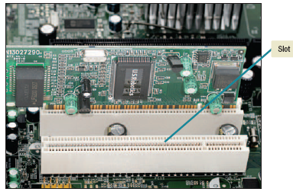

**Figure 6.9: Expansion cards fit into slots in the system board**



**Figure 6.10: Expansion card with three ports**

Most microcomputers allow users to expand their systems by providing **expansion slots** on the system board. Users can insert optional devices known as **expansion cards** into these slots. Ports on the cards allow cables to be connected from the expansion cards to devices outside the system unit (see figures 6.9 and 6.10). There are a wide range of different types of expansion cards. Some of the most commonly used expansion cards are

* **Graphics cards** provide high-quality 3D graphics and animation for games and simulations.
* **Sound cards** accept audio input from a microphone and convert it into a form that can be processed by the computer. Also, these cards convert internal electronic signals to audio signals so they can be heard from external speakers or home theater systems.
* **Network interface cards** also known as **network adapter cards,** are used to connect a computer to a network. The network adapter card typically connects the system unit to a cable that connects to the network.
* **Wireless network card** allows computers to be connected without cables.
* **TV tuner cards** contain a TV tuner and a video converter that changes a traditional TV signal into one that can be displayed on your monitor. With these, you can watch TV, capture video, and surf the Internet at the same time.

**Plug and Play** was originally a set of specific hardware and software standards developed by Intel, Microsoft, and others. As hardware and software have evolved, however, Plug and Play has become a generic term that is associated with the ability to plug any device such as a printer or monitor into a computer and have it play or work immediately. Some devices, however, are not “Plug and Play” and require that new device drivers be installed.

To meet the size constraints of notebook and handheld computers, small credit card–sized expansion cards known as ***PC cards*** have been developed. These cards plug into PCMCIA slots (called **PC Cards slots**) or, most recently, **ExpressCard** slots.



**Figure 6.10 PC Card**

**6.6 Bus lines**

A **bus line** —also known simply as a **bus** —connects the parts of the CPU to each other. Buses also link the CPU to various other components on the system board. A bus is a pathway for bits representing data and instructions. The number of bits that can travel simultaneously down a bus is known as the **bus width.** A bus is similar to a multilane highway that moves bits rather than cars from one location to another. The number of traffic lanes determines the bus width. A highway (bus line) with more traffic lanes (bus width) can move traffic (data and instructions) more efficiently. For example, a 64-bit bus can move twice as much information at a time as a 32-bit bus. Why should you even care about what a bus line is? Because as microprocessor chips have changed, so have bus lines.

Every computer system has two basic categories of buses. One category, called **system buses,** connects the CPU to memory on the system board. The other category, called **expansion buses,** connects the CPU to other components on the system board, including expansion slots.

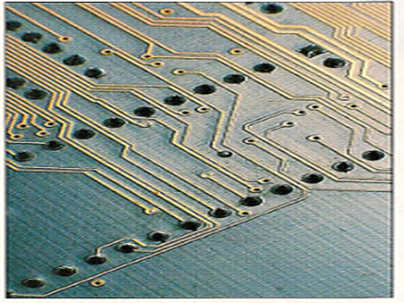

**Figure 6.11: Bus is a pathway for bits**

**6.6.1 Expansion buses**

Computer systems typically have a combination of different types of expansion buses. The principal types are PCI, USB, Firewire, SATA, and PCIe.

* **Peripheral component interconnect** (**PCI**) was originally developed to meet the video demands of graphical user interfaces. When first introduced, it had a 32-bit bus width and was over 20 times faster than the older buses that it replaced. Almost all PCI buses are now 64-bit and are very common on older computers.
* **Universal serial bus (USB)** is widely used today. It combines with a PCI bus on the system board to support several external devices without using expansion cards or slots. External USB devices are connected from one to another or to a common point or hub and then onto the USB bus. The USB bus then connects to the PCI bus on the system board. The current USB standard is USB 3.0.
* **FireWire buses** are similar to USB buses but are more specialized. They are used primarily to connect audio and video equipment to the system board.
* **Serial Advanced Technology Attachment (SATA)** bus is one of the newest buses. It is much faster than USB 3.0 and FireWire buses and is now widely used to connect high-speed storage devices to the system board.
* **PCI Express (PCIe)** is widely used in many of today’s most powerful computers. Unlike the PCI bus and most other buses that share a single bus line or path with several devices, the PCIe bus provides a single dedicated path for each connected device. PCIe buses are much faster and are replacing the PCI bus.

**6.7 Ports**

A **port** is a socket for external devices to connect to the system unit. Some ports connect directly to the system board while others connect to cards that are inserted into slots on the system board. Some ports are standard features of most computer systems and others are more specialized.

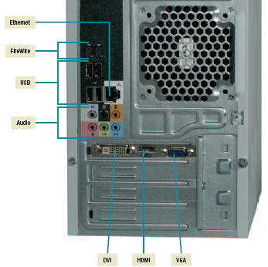

**Figure 6.12: Ports**

**6.7.1 Standard ports**

Most microcomputers come with a standard set of ports for connecting a monitor, keyboard, and other peripheral devices. The most common ports include:

* **VGA (Video Graphics Adapter) and DVI (Digital Video Interface) ports** provide connections to analog and digital monitors, respectively. DVI has become the most commonly used standard, but VGA ports are still provided on almost all systems for compatibility with older/lower-cost monitors.
* **Universal serial bus (USB) ports** can be used to connect several devices to the system unit and are widely used to connect keyboards, mice, printers, and storage devices to the system unit. A single USB port can be used to connect many USB devices to the system unit.
* **FireWire ports** provide high-speed connections to specialized FireWire devices such as camcorders and storage devices.
* **Ethernet ports** are a high-speed networking port that has become a standard for many of today’s computers. Ethernet allows you to connect multiple computers for sharing files, or to a DSL or cable modem for high-speed Internet access.

**6.7.2 Specialized ports**

In addition to standard ports, there are numerous specialty ports including S/PDIF, HDMI, and MIDI.

* **Sony/Philips Digital Interconnect Format (S/PDIF)** ports are also known as **optical audio connections.** These ports are used to integrate computers into high-end audio and home theatre systems.
* **High Definition Multimedia Interface (HDMI)** ports provide high definition video and audio, making it possible to use a computer as a video jukebox or an HD video recorder.
* **Musical instrument digital interface (MIDI)** ports are a special type of serial port for connecting musical instruments like an electronic keyboard to a sound card. The sound card converts the music into a series of digital instructions. These instructions can be processed immediately to reproduce the music or saved to a file for later processing.
* **Mini DisplayedPort (MiniDP or mDP)** ports are an audiovisual port typically used to connect large monitors. These ports are used with many Apple Macintosh computers.

**6.7.3 Cables**

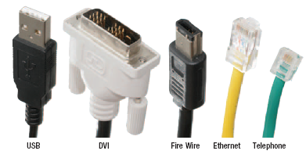

**Cables** are used to connect exterior devices to the system unit via the ports. One end of the cable is attached to the device and the other end has a connector that is attached to a matching connector on the port.

**6.8 Power supply**

Computers require direct current (DC) to power their electronic components and to represent data and instructions. DC power can be provided indirectly by converting alternating current (AC) from standard wall outlets or directly from batteries.

* Desktop computers have a **power supply unit** located within the system unit. This unit plugs into a standard wall outlet, converts AC to DC, and provides the power to drive all of the system unit components.

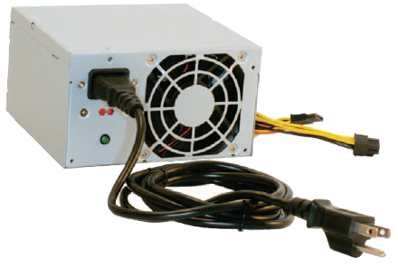

**Figure 6.14: Power supply unit**

* Notebook and tablet PCs use **AC adapters** that are typically located outside the system unit. AC adapters plug into a standard wall outlet, convert AC to DC, provide power to drive the system unit components, and can recharge the batteries. These computers can be operated either using an AC adapter plugged into a wall outlet or using battery power. Their batteries typically provide sufficient power for 9 to 10 hours before they need to be recharged.

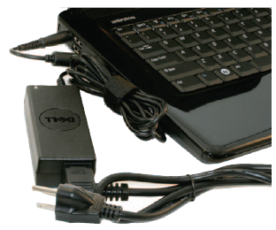

**Figure 6.15: AC adapter**

* Like notebook and tablet PCs, netbook and handheld computers use AC adapters located outside the system unit. Unlike notebook and tablet PCs, however, netbook and handheld computers typically operate only using **battery power**. The AC adapter is used to recharge the batteries.

**6.9 Electronic data and instructions**

Have you ever wondered why it is said that we live in a digital world? It’s because computers cannot recognize information the same way you and I can. People follow instructions and process data using letters, numbers, and special characters. For example, if we wanted someone to add the numbers 3 and 5 together and record the answer, we might say “please add 3 and 5.” The system unit, however, is electronic circuitry and cannot directly process such a request.

Our voices create **analog,** or continuous, signals that vary to represent different tones, pitches, and volume. Computers, however, can recognize only **digital** electronic signals. Before any processing can occur within the system unit, a conversion must occur from what we understand to what the system unit can electronically process.

**6.9.1 Numeric representation**

Electricity can be either on or off. Indeed, there are many forms of technology that can make use of this two-state on/off, yes/no, present/absent arrangement. For instance, a light switch may be on or off, or an electric circuit is open or closed. A specific location on a tape or disk may have a positive charge or a negative charge. This is the reason, then, that a two-state or binary system is used to represent data and instructions.

The **binary system** consists of only two digits—0 and 1. Each 0 or 1 is called a **bit** —short for **bi**nary digi**t**. In the system unit, the 1 can be represented by a positive charge and the 0 by no electrical charge. In order to represent numbers, letters, and special characters, bits are combined into groups of eight called **bytes.** Whenever you enter a number into a computer system, that number must be converted into a binary number before it can be processed.

Binary numbers, however, are difficult for humans to work with because they require so many digits. Instead, binary numbers are often represented in a format more readable by humans. The **hexadecimal system,** or **hex,** uses 16 digits (0, 1, 2, 3, 4, 5, 6, 7, 8, 9, A, B, C, D, E, F) to represent binary numbers. Each hex digit represents four binary digits, and two hex digits are commonly used together to represent 1 byte (8 binary digits).

|  |  |  |
| --- | --- | --- |
| **Decimal system** | **Binary system** | **Hex system** |
| 00 | 00000000 | 00 |
| 01 | 00000001 | 01 |
| 02 | 00000010 | 02 |
| 03 | 00000011 | 03 |
| 04 | 00000100 | 04 |
| 05 | 00000101 | 05 |
| 06 | 00000110 | 06 |
| 07 | 00000111 | 07 |
| 08 | 00001000 | 08 |
| 09 | 00001001 | 09 |
| 10 | 00001010 | 0A |
| 11 | 00001011 | 0B |
| 12 | 00001100 | 0C |
| 13 | 00001101 | 0D |
| 14 | 00001110 | 0E |
| 15 | 00001111 | 0F |

**Table 6.1: Numeric representation**

**6.9.2 Character encoding**

How can a computer provide representations of the nonnumeric characters we use to communicate, such as the sentence you are reading now? The answer is character encoding schemes or standards.

**Character encoding standards** assign a unique sequence of bits to each character.

* Historically, microcomputers used the **ASCII (American Standard Code for Information Interchange)**
* Mainframe computers used **EBCDIC (Extended Binary Coded Decimal Interchange Code).**
* **Unicode:** uses a variable number of bits to represent each character, which allows non-English characters and special characters to be represented.

The ASCII and EBCDIC were quite effective but were limited. ASCII, for example, only uses 7 bits to represent each character, which means that only 128 total characters could be represented. This was fine for most characters in the English language but was not large enough to support other languages such as Chinese and Japanese. These languages have too many characters to be represented by the 7-bit ASCII code.

The explosion of the internet and subsequent globalization of computing led to the Unicode encoding which uses 16 bits. The Unicode standard is the most widely used character encoding standard and is recognized by virtually every computer system.

When you press a key on the keyboard, a character is automatically converted into a series of electronic pulses that the system can recognize. All the instructions and data have to be converted into binary data before they can be executed.

Table 6.1 shows some examples from the ASCII and EBCDIC encoding systems.

|  |  |  |
| --- | --- | --- |
| **Symbol** | **ASCII** | **EBCDIC** |
| A | 0100 0001 | 1100 0001 |
| B | 0100 0010 | 1100 0010 |
| C | 0100 0011 | 1100 0011 |
| D | 0100 0100 | 1100 0100 |
| ! | 0010 0001 | 0101 1010 |
| ‘’ | 0010 0010 | 0111 1111 |
| # | 0010 0011 | 0111 1011 |
| % | 0010 0100 | 0110 1100 |

**Table 6.2: Examples of ASCII and EBCDIC encoding system**